***PROJECT REPORT***

**On**

Smart Dustbin

**Appartus:**

* **Arduino UNO**
* **HC-SR04 Ultrasonic Sensor Module**
* **TowerPro SG90 Servo Motor**
* **Connecting Wires**
* **5V Power Supply**
* **A small dustbin with hinged lid**
* **Miscellaneous (glue, plastic tube, etc.)**

**Circuit Diagram:**

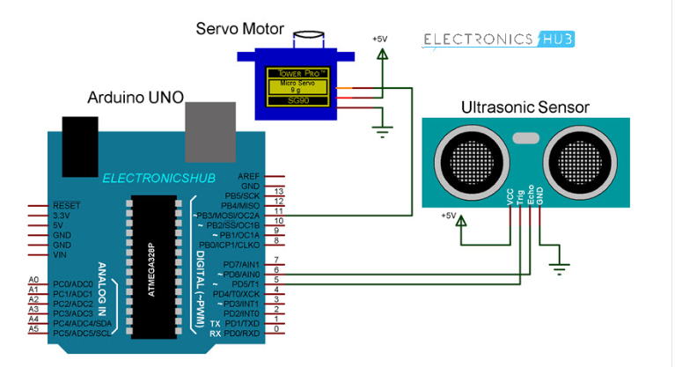

**Sketch:**

**#include <Servo.h>**

**int gnd=12;**

**int echo=10;**

**int trig=11;**

**Servo myservo;**

**int VCC=13;**

**float duration=0;**

**float distance=0;**

**float height=0;**

**float level=0;**

**void setup() {**

**Serial.begin(9600);**

**pinMode(echo,INPUT);**

**pinMode(trig,OUTPUT);**

**pinMode(VCC,OUTPUT);**

**pinMode(gnd,OUTPUT);**

**digitalWrite(VCC,HIGH);**

**digitalWrite(gnd,LOW);**

**Serial.println("Distance");**

**myservo.attach(9);**

**myservo.write(0);**

**}**

**void loop() {**

**digitalWrite(trig,HIGH);**

**delayMicroseconds(10);**

**digitalWrite(trig,LOW);**

**duration=pulseIn(echo,HIGH);**

**distance=(duration*0.0347)/2;**

**Serial.println(distance);**

**delay(1000);**

**if(distance<30)**

**{**

**myservo.write(90);**

**}**

**else**

**myservo.write(0);**

**}**

**Working**

After setting up the Smart Dustbin and making all the necessary connections, upload the code to Arduino and provide 5V power supply to the circuit. Once the system is powered ON, Arduino keeps monitoring for any object near the Ultrasonic Sensor.

If the Ultrasonic Sensor detects any object like a hand for example, Arduino calculates its distance and if it less than a certain predefined value, Arduino will activate the Servo Motor and with the support of the extended arm, it will list the lid open.

After certain time, the lid is automatically closed.

---------------------------------Thank You-------------------------------